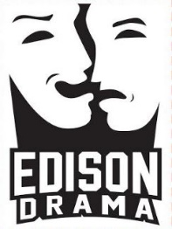

Thomas Edison High School (Drama Department)
5801 Franconia Road
Alexandria, VA 22310

Dear Local Business Owner & Supporters of the Arts:

Thank you for your interest in Edison High School’s Drama program! Your paid advertisements help support our live productions and drama curriculum throughout the year. Our students spend hundreds of hours after school and on weekends working on our productions. They are not only learning the fine art of drama, but lessons in teamwork, leadership, and responsibility. These are life-changing experiences that will shape their lives for years to come.

The Eagles Drama Boosters provides lumber, paint, costumes, props, food (lots of food!) and volunteers (lots of volunteers!) – all in support of our kids - many of whom are probably right in your neighborhood. #TheatreChangesLives. And we couldn’t do it without you.

Our upcoming production of Cinderella will have six performances and we hope to attract 2,000+ attendees across our run. Advertising in our Cinderella show program will give you access to valuable local customers who are likely to buy your products and services. Our theatre-goers love to support local businesses and we’d like nothing more than to tell them about your business. Don’t miss this great opportunity to reach a valuable customer base for a very modest investment.

We can accept camera-ready ads in the sizes listed on the advertising form. You can choose a full page, half page or quarter page. There are also additional sponsorship opportunities available (how about your logo on EVERY SINGLE TICKET that we sell??).

Thank you for your support of our ever-growing and evolving drama program. We greatly appreciate it. Please feel free to email President@edisondrama.com should you have any questions or need assistance.

Sincerely,

Eagles Drama Boosters

Visit us on the web or buy tickets at www.edisondrama.com.

